Simplicity analysis of “Uncle Sam”

Kun Yang

ENG 112-100

Margaret Neff

Due:6/10/2015

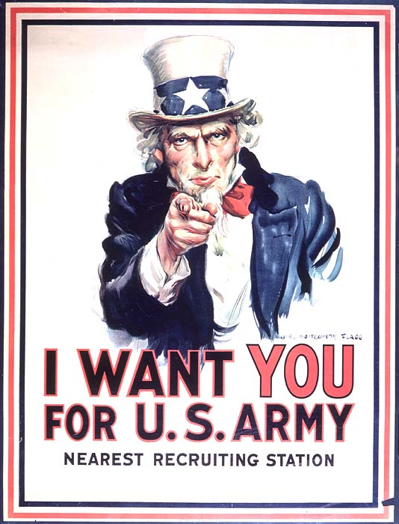

Figure 1: “James Montgomery Flagg(1877-1960) ‘I Want You for the U.S. Army’ Lithograph,1917”

Originally painted by James Montgomery Flagg on July 6th, 1916, this now-famous poster first appearedin Leslie’s Weekly “What Are You Doing for Preparedness?” Over four million copies of “Uncle Sam” were printed between 1917 and 1918 to recruit American soldiers for the U.S Amry in World War I and then again in World War II.

The “Uncle Sam” image was intended to appeal to American citizens, Even Though its slogan specifies the Army, it’s clear the poster is intended for the USA military in general, with its patriotic colors, its depiction of a paternalistic uncle embodying the entire country, and its individualized appeal with the term, you.

The red, white and blue patriotic color out frame directly gave such image that it was made for the American audiences. Another piece of evidence where the white American elderly male figure pointing at the readers, where the male figure is wearing a blue jacket, white 1890s tall patriotic white hat, red bowtie, and a white shirt, the image intended him to be someone who was a boss or political figure from the industrial revolution period, which in a sense that the higher class of America also need “you” who were the readers to join the Army, in order to keep the peace around the world. The Uncle Sam figure was based on the model of Samuel Wilson, a meat packer from Troy, New York. “Samuel Wilson…Who supplied barrels of beef to the United States Army during the War of 1812. Wilson stamped the barrels with U.S. for United States, but soldiers began referring to the grub as Uncle Sam’s.”(Hisotry.Com)

This image used both Logos and Pathos from the rhetorical triangle, with the text “I Want You For U.S.ARMY” as the central expressive idea of this image, which is connected to the Logos From the rhetorical triangle. Meanwhile the White American Male figure in the background where he was pointing at the readers as a meaning that USA had chosen the readers who was the American citizen at the time as the candidates of the purpose of such image, as intended that the white American male focused on the audience; “Uncle Sam’s eyes” were heavily emphasized as symbolic of trust, where the eyes were heavily focused in the middle of the page. Two appeals combine as the equivalence of the Pathos from the rhetorical triangle. This image was effective, as verified by the American Treasures of the Library of Congress, “over four million copies were printed between 1917 and 1918”(loc.gov)which emphasizes the massive numbers of to attest to the effectiveness of the image as a whole.

This image had impressed me as motivation of joining the military; however figure-one has its shortcomings, for examples it strikes readers that such image has included racist ideas, because at such period, the African American minorities were not fully incorporated into the American society; therefore, I think the image would had been better, if the image would include a few different versions, with the central character having various, multi-racial versions. It would have been perfect if the poster also appealed to females, too.

My first response to the image was motivated by Uncle Sam pointing straight at me; I felt personally motivated because he seems to be singling me out and because I agreed with the image’s implicit message which emphasized my obligation to serve my country.

Works cited

“I Want You for the U.S Army” James Montgomery Flagg,1917

History.com Staff. “United States nicknamed Uncle Sam” A+E Networks. 2009

American Treasures of the Library “The Most Famouse Poster” Library of Congress. July 27th,2010